**CODE -1**

# Import the required libraries

from sklearn.tree import DecisionTreeClassifier

import pandas as pd

from sklearn.metrics import confusion_matrix, accuracy_score, classification_report

from sklearn.model_selection import train_test_split

pima = pd.read_csv('Book1.csv')

print(pima)

x=pima.iloc[:,:5]

y=pima.iloc[:,5]

xTr,xTe,yTr,yTe=train_test_split(x,y,test_size=0.2)

dtc=DecisionTreeClassifier()

dtc.fit(xTr,yTr)

yPred=dtc.predict(xTe)

print(confusion_matrix(yTe,yPred))

print(accuracy_score(yTe,yPred))

print(classification_report(yTe,yPred))

**OUTPUT:**

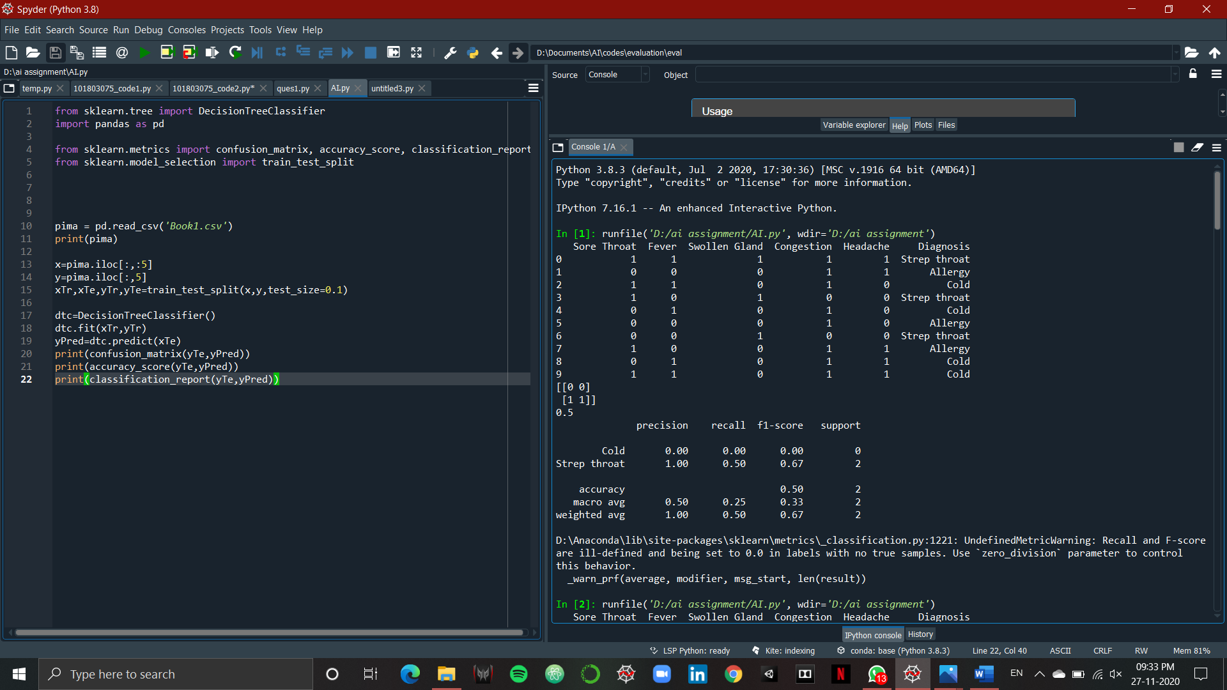

**CODE-2:**

/*----- Facts -----*/

person(alice).

person(husband).

person(son).

person(daughter).

person(brother).

child(son).

child(daughter).

male(husband).

male(son).

male(brother).

female(alice).

female(daughter).

twin(alice, brother).

twin(brother, alice).

twin(son, daughter).

twin(daughter, son).

/*----- Rules -----*/

istwin(X) :- twin(X, _).

older(alice, son).

older(alice, daughter).

older(husband, son).

older(husband, daughter).

inbar(M, N) :- person(M), person(N),

male(M), female(N).

together(S, T) :- S=alice, T=husband.

together(S, T) :- T=alice, S=husband.

alone(P) :- person(P), child(P).

/*----- Rule Combining Clues -----*/

solution(Killer, Victim, InBarA, InBarB, Alone) :-

person(Killer), person(Victim),

/* The victim's twin was innocent. */

istwin(Victim), \+ twin(Victim, Killer),

/* The killer was younger than the victim. */

\+ older(Killer, Victim),

/* not the same as "older(Victim, Killer)"! */

/* Alice and her husband were not together

at the time of the murder. */

\+ together(Killer, Victim), Killer \= Victim,

/* A man and a woman were together in the

at the time of the murder. */

inbar(InBarA, InBarB),

InBarA \= Killer, InBarB \= Killer,

InBarA \= Victim, InBarB \= Victim,

/* Alice and her husband were not together

at the time of the murder. */

\+ together(InBarA, InBarB),

/* One of the children was alone at the

time of the murder. */

alone(Alone),

Alone \= InBarA, Alone \= InBarB,

Alone \= Killer, Alone \= Victim.

/*----- Goal -----*/

print_solution :-

/* Find the solution */

solution(Killer, Victim, InBarA, InBarB, Alone),

/* Write solution */

nl,

write(Killer), write(' killed '), write(Victim), write('.'), nl,

write(InBarA), write(' and '), write(InBarB),

write(' were together in the bar.'), nl,

write(Alone), write(' was alone.'), nl, nl.

?- print_solution. /* Run it */

**OUTPUT:**

